Where is Latin American going?
Alan Freeman
This discussion document makes an initial assessment of the political and economic developments that underlying the complex and shifting developments in Latin America. These developments
- are provoked by the US-led wave of financial deregulation which began in 1980. Specifically they respond to the economic failure of this project to create a social basis for pro-IMF and pro-US governments in Latin America.
- They have unleashed political processes and establish governments which threaten US dominance of the world order. If their present policies continue to evolve in a radical manner, they offer a real obstacle to the growth of US dominance in the third world and a real prospect of a social and economic alternative to this dominance.

What happened in the 1980s?
The background to the entire process is the process which opened in 1982 with the Reagan-Thatcher reconstruction of the IMF and world bank in what has been termed the ‘neoliberal counterrevolution.’ The debt crisis in the third world – beginning in Mexico – became the principal instrument through which the advanced countries, under the leadership of the US, brought about world financial deregulation and a more or less common economic programme of privatisation, deregulation and the opening of third world markets to both the goods and the capital of the North.
Chart 1: Share of world income Advanced The rest
1970 | 1980 | 2000
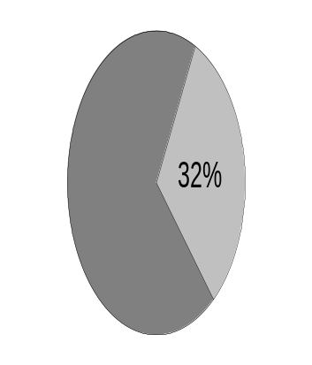 | 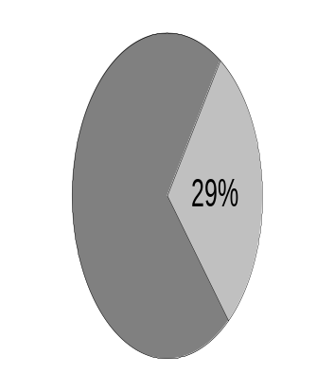 | 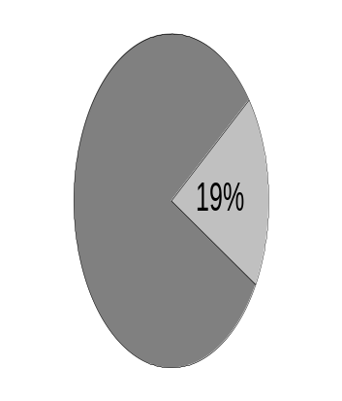
Chart 2: Share of world population Advanced The rest
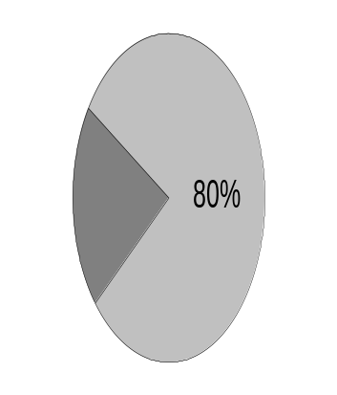 | 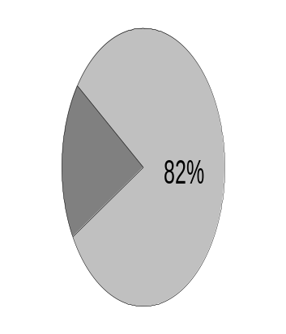 | 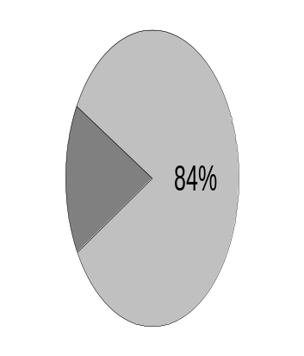

The economic consequence of this period of ‘neoliberal globalisation’ has been threefold. First of all it brought about stagnation, and relative decline of the whole of the third world including Latin America compared with the whole of the advanced world,
This is shown in Chart 1 which shows the share of world income produced in the countries which the IMF calls ‘Advanced’ compared with the rest of the world, and chart 2 which shows the population of these countries.
Table 1 GDP per capita in constant 1995 dollars
 |  |  |  |  |  | Annual Growth rate, per cent
 | 1970 | 1980 | 1990 | 2000 | 2002 | 1970-1980 | 1980-2002
Advanced countries | $10,473 | $18,088 | $23,989 | $26,201 | $25,672 | 5.6 | 1.8
Rest of the World | $1,248 | $1,690 | $1,356 | $1,160 | $1,100 | 3.1 | -2.1
Ratio of GDP per capita, Advanced/Rest of the world | 8.4 | 10.7 | 17.7 | 22.6 | 23.3 | 2.4 | 3.9
Population of the Advanced Countries(millions) | 718 | 778 | 827 | 833 | 845 | 0.4 | 0.8
Population of the Rest of the World(millions) | 2,810 | 3,466 | 4,213 | 4,288 | 4,431 | 1.2 | 2.1
Source: IMF world economic outlook and Freeman and Kagarlitsky (eds) (2004) The politics of Empire, London: Pluto
Between 1980 and 2000 the rest of the world’s share shrank from just under 30 per cent of the whole world’s income to just under 20 per cent. At the same time, the proportion of people living there rose from 80 per cent to 84 per cent.
It follows that when the present stage of globalisation began, dating this as 1980, the income of the advanced countries was 11 times larger, in proportion to their population, than the rest of the world. By 2000 this ratio had hence risen to 23.
Table 2 provides the underlying data and establishes that the process involved stagnation as well as polarisation. That is, the world is getting more unequal not just because the rich countries are growing faster than the poor countries, but because the poor countries (containing four-fifths of the world’s population) are actually in decline.
Globalisation secondly, however brought about a geographical convergence in the major third world regions, particularly in Latin America as shown in table 2. The differences between average (per capita) income and output of all countries in Latin America has significantly lessened – excluding to a greater and greater degree the option for any country to follow an individual road to wealth on the model of, for example, Slovenia or Estonia. This lies behind the highly significant victory of the Frente Amplio in Uruguay, previously designated ‘Latin America’s Switzerland’.
Table 2 Regional inequality in Latin America – ratio of average income to that of bottom (poorest) 20 per cent
 | 1970 | 1975 | 1980 | 1985 | 1990 | 1995 | 2000 | 2001 | 2002
Quintile 2 (second most poor 20 per cent of countries) | 1.26 | 1.44 | 1.28 | 1.79 | 2.38 | 1.77 | 2.01 | 1.73 | 1.65
Quintile 3 | 1.42 | 1.54 | 1.32 | 1.93 | 3.15 | 2.23 | 2.29 | 1.87 | 1.72
Quintile 4 | 2.60 | 2.77 | 2.94 | 2.49 | 3.17 | 2.61 | 3.43 | 3.35 | 2.36
Quintile 2 (richest 20 per cent of countries) | 5.24 | 3.84 | 3.95 | 3.39 | 3.72 | 3.45 | 4.33 | 4.20 | 4.22
Source: ibid
Globalisation thirdly produced social polarisation within Latin America itself, driving the great mass of people, even in middle-income countries as Uruguay or Argentina, down to levels at which even survival is questionable. It is important to understand that this involves levels of inequality and poverty which find absolutely no comparison in the imperialist countries and this is something which is not understood by many in the antiglobalisation movement.
Table 3: Per Capita Household Income Distribution (select countries)
% of GDP | 1980 |  | 1989
 | Poorest 20% | Richest 20% | Poorest 20% | Richest 20%
Argentina | 5.3 | 46.6 | 4.1 | 52.6
Brazil | 2.6 | 64.0 | 2.1 | 67.5
Chile | -- | -- | 3.7 | 62.9
Colombia | 2.5 | 63.0 | 3.4 | 58.3
Guatemala (1987) | 2.7 | 62.0 (1989) | 2.1 | 63.0
Mexico (1984) | 4.1 | 55.9 | 3.2 | 59.3
Peru (1986) | 6.2 | 49.7 | 5.6 | 50.4
Venezuela (1981) | 5.0 | 47.3 | 4.8 | 49.5
Source: World Bank and William I Robinson ‘The Crisis of Global Capitalism: how it Looks from Latin America’ in Freeman and Kagarlitsky, op cit
A ‘simple’ identification between struggles against neoliberalism and in Latin America is completely misleading. This is not only because of the level of poverty - the standard of living of the bottom ten percent of any advanced country is a level which a middle income family in Latin America would aspire to in its dreams – but because the levels of inequality which produce a political instability way outside what is to be found in Northern parliamentary democracies. It is this extreme polarisation that produces movements such as the ‘caceralazo’ in Argentina, and the Venezuelan revolutionary process.
In Argentina for example, the ratio between the average income of the highest and lowest decile of the population has risen from 12 to 1 under Peron, to 100 to one today. In the UK this ratio is around 8. In Argentina – a rich country by Latin American standards – seven million Argentinians are now ‘indigent’ which is defined to means that they cannot afford a meal every day. The Venezuelan and other such processes are driven by even more crushing levels of poverty.
Table 4: Percentage of Population Living Below $2 Per Day (Poverty) and $1 Per Day, Select Countries and Years
 | % Below $2 | % Below $1
Argentina (1991) | 25.5 | N/A
Brazil (1995) | 43.5 | 23.6
Mexico (1992) | 40 | 14.9
Panama (1989) | 46.2 | 25.6
Colombia (1991) | 21.7 | 7.4
Dominican Republic (1989) | 47.7 | 19.9
Ecuador (1994) | 65.8 | 30.4
Guatemala (1989) | 76.8 | 53.3
Venezuela (1991) | 32.2 | 11.8
Chile (1992) | 38.5 | 15
Nicaragua (1993) | 74.5 | N/A
Honduras | 75.7 | N/A
Source: ibid

Globalisation fourthly uprooted the traditional bourgeoisies in Latin America. As a result of the increased intrusion of finance capital and privatisation, a growing ‘transnational’ layer of the bourgeoisie has simply sold its direct stake in production to foreign interests and has become a rentier class which throws in its lot with the fate of international finance capital. Not only has this led to unprecedented levels of corruption but has deprived these newly-enriched classes of their traditional basis in the middle classes. This took extreme forms in Venezuela where virtually every political party divided into a pro-Chavez and an anti-Chavez wing and also in Argentina, where the collapse of the currency plunged millions of relatively wealthy ‘middle people’, whose savings were held in the Argentine banking system, into abrupt poverty, producing a social explosion and bringing about the collapse of four presidencies in as many weeks.
The outcome is thus that governments in an increasing area of the continent depend for their stability on whether or not they defend the demands and gains of a very large poor majority which is on the offensive, launching more and more determined and conscious struggles against against international financial interests – specifically the International Financial Institutions – and, increasingly, against explicit US military and commercial interests. Chavez has for the first time since 1980 initiated a programme of socially revolutionary measures in Central America. Governments nominally supportive of the anti-neoliberal demands of the mass movement are now in power in the whole Southern Cone (Argentina, Brasil, Chile, Uruguay, Paraguay). The paralysis of government in Bolivia has in effect abdicated the question ‘who will rule’ to a contest on the streets. This is clear from Condoleeza Rice’s characterisation of Venezuela as a ‘significant destabilising factor in the region’ and in Venezuela’s identification by neocon forces as a ‘third axis of evil’

The particular significance of debt in Latin America
A further decisive factor is the particular role of debt in the political control of Latin America. The neoliberal counterrevolution began with the Mexican debt crisis of 1982 provoked by the build-up of debt in the preceding decade. The high-interest-rate régimes initiated by Reagan and Thatcher meant that the large debts accumulated during the era of cheap money, all of which were denominated in dollars, now demanded completely unsustainable interest payments.
Table 4: Annual Growth Rate of Latin America’s Debt
Years | 1979-81 | 1982-3 | 1984-90 | 1991-3 | 1994-6 | 1997-99
Percentage Growth | 22.9 | 11.2 | 3.2 | 4.6 | 10.4 | 5.5
Source: ECLAC, op. cit., reports 1985 and 1994-95 and Robinson, op cit
Table 5: Latin America’s External Debt ($billion)
Year | 1980 | 1985 | 1990 | 1991 | 1992 | 1993 | 1994 | 1995 | 1996 | 1997 | 1998 | 1999
Debt | 230 | 374 | 442 | 457 | 475 | 506 | 533 | 653 | 676 | 714 | 786 | 793
Source: World Bank, 1998-2000, Country Tables, pp. 36 and Robinson,op cit
This transformed the role of the IMF which was established initially as a simple financial institution to ‘regulate’ currency and exchange rates worldwide – a kind of ‘central bank of central banks’. The IMF was able to broker a relation between private capital worldwide and the Mexican government. In return for financial aid, the Mexican government had to submit to a political programme defined by the IMF which then became the pattern for IMF intervention – the so-called ‘Stability Adjustment Programmes’ or SAPs. SAPs became the principal instrument by means of which neoliberal programmes were imposed on the governments of the region and hence the principal actual form taken by what might be termed ‘formal globalisation’ – substituting an internationally defined political policy for the sovereign policies determined by national governments.
But in fact, all the theoretical arguments proposed by the globalisers to prove that this process is in some sense an inevitable and progressive tendency of the world market, equally well establish that they are the consequence of a conscious political initiative of the United States acting on concert with European and Japanese capital. To claim that this is some kind of ‘unconscious’ tendency of the market is to forget that the IFIs are anything but ‘unthinking’ instruments but are composed of, and governed by, national states. The appointment of Wolfowitz to the IMF is only the somewhat cynical re-assertion of what has always been the case.
Debt was therefore an instrument of political control and has to be understood as such, and is so understood by an increasing layer of the Latin American masses. An important part of the process through which this consciousness is growing – and through which neoliberal political forces are becoming discredited – is the realisation that the IMF is not an impartial technical team but an open expression of US interests in the region.
In fact the argument that financial deregulation created the basis for a much-needed inflow of capital is a cruel deception. Latin America as a whole, and many Latin American countries, run an export surplus. They have no special need to import capital and in fact, since Argentina has defaulted on its debt, with no access to capital markets at all it has shown double-digit growth. As table 6 shows, during the early period of ‘globalisation’ interest payments greatly exceeded inward capital flows; during even the highest years of capital inflow in the 1990s they were a substantial proportion of inward flows, and by the end of the 1990s the continent had resumed net outflow.
Table 4: Net Capital Flows, Net Payment on Profits and Interest, and Net Resource Transfer ( in billions of dollars)
 | Net Capital Flows | Net Payments Profit/Interest | Net Transfer
1982-1990 | 99 | 318 | -219
1991-1995 | 266 | 174 | 92
1996 | 65 | 43 | 22
1997 | 81 | 48 | 33
1998 | 78 | 51 | 27
1999 | 47 | 52 | -5
2000 | 53 | 53 | 0
2001 | 50 | 55 | -5
2002 | 13 | 53 | -40
Source: Compiled from ECLAC (2000, 2001, 2002)

Moreover the principal function of these inflows was not the regeneration of the economy but its purchase. As table 7 shows, the proceeds of privatisation – which count as a ‘capital inflow’ but in fact constitute a simple transfer of ownership – exceeded or equalled FDI for three of the first five years of the 1990s and remained a large part thereafter. Moreover a high proportion of capital inflows is liquid and highly volatile, as the high proportion of Bond ownership demonstrates. This capital withdraws during a crisis in the financial system, throwing country after country into political turmoil.
Table 5: Net Foreign Investment, International Bond Issues, and Proceeds Sale of Public Enterprises, Latin America and Selection Countries (in $millions)
 | 1991 | 1992 | 1993 | 1994 | 1995 | 1996 | 1997 | 1998 | 1999 | 2000
Latin America
Net FDI | 11,066 | 12,506 | 10,363 | 23,706 | 24,799 | 39,387 | 55,580 | 61,596 | 77,047 | 57,410
Int. Bond Issues | 7,192 | 12,577 | 28,794 | 17,941 | 23,071 | 46,915 | 52,003 | 39,511 | 38,707 | 35,816
Proceeds from privatisation | 16,702 | 14,886 | 10,179 | 8,529 | 3,433 | 11,458 | 24,408 | 42,461 | N/A | N/A

This volatility is, finally, intimately bound up with the emergence of a new rentier class within Latin America which has converted its fortunes increasingly into international assets. At the end of the Plan Cavallo in Argentina – the disastrous attempt to peg the peso to the dollar which led to its collapse in 2002 – the rise in Argentine debt was more or less exactly equal, at all points in time, to the quantity of liquid capital which had fled the country. For this reason the crisis drove a cleaver through the middle classes dividing them into a small rich and upper class layer possessing dollar assets, who were largely immune to the crisis (except of course for its political consequences) and the majority of ‘small middle class’ people whose savings were in pesos, which were locked in the banking system and devalued to a third of their former value.
This volatility of capital inflows, and the failure to bring about any structural regeneration of the economies of Latin America, is, apart from a stunning demonstration of the imbecilic idiocy IMF policies, the fundamental reason behind the political instability of the region.

Political capabilities of the leaderships
The political leadership of the movement is at present inadequate, taken as a whole, to the realisation of the possibilities spelt out above. Nevertheless what has to be understood is the dynamic of the process and the means to maximise the chances of a successful outcome and for this reason, solidarity with Latin America should have greatly heightened priority. Key points are that
- The process is pushing more and more radical forces to the forefront – exemplified in the uncompromising stance of the Chavez government which has not only wrested control of oil production from its pro-imperialist employers and their corrupt workforce, using the proceeds to finance a major redistributive programme of social provision targetted at the extreme poor who make up 80 per cent of the population but is extending to socially revolutionary measures such as land redistribution. No less significant in terms of its impact on imperialist control of the region is the successful and unprecedented renegotiation of Argentina’s IMF-imposed debt at 25 per cent of its nominal value
- These developments are modifying the stance of those inclined to compromise and, at present, driving them away from alignment with imperialism, although not necessarily into defence of the needs of the masses. The most rightwing among the ‘left’ governments – that of Lula in Brazil – compromised not only its economic future but its political support by the complying with the demands of the IMF. But the success of Kirchner in Argentina – impelled by a mass popular revolt of 2002 – definitively showed that the political and economic conditions exist to stand up to the IFIs and hence to the international programme of neoliberalism. Lula’s discomfiture manifests itself in support for the most radical measures proposed by Chavez within Mercosur including the establishment of continental economic institutions such as Petrosur, a proposed Latin America oil company, and Radiosur, a proposed Latin American radio station, and more practically in wholehearted solidarity with Venezuela against attempted US diplomatic manouvres preparatory for military intervention.
- Increasingly, openly capitulationist or fake anti-imperialist forces are either marginalised (as in Bolivia) or have seen the revival of significant forces to their left. This is particularly noteworthy in Chile, the lynchpin of imperialist geopolitical strategy in the Southern Cone, where Juntos Podemos (Together We Can), the electoral alliance created by the Communist and Humanist parties along with smaller left-wing forces that do not legally exist as parties, took three or four city governments, with over nine percent of the votes for city councillors and nearly six per cent for mayors – virtually guaranteeing that rightwing socialist president Lagos will have to include these forces in preparing coalitions for the 2006 elections.
- Rightwing or pro-imperialist forces are disoriented and divided. The two most decisive facts in securing Chavez’s victories both against the 2002 attempted coup and in the subsequent recall referendum were first, the extent of the mass mobilisation, and second, the absolute indecisiveness of, and the open divisions among, the opposition.

The coming US counteroffensive
Correcting the political weakness of its own supporters is the immediate objective of US diplomacy in the region so that the present favourable situation should be regarded as a breathing space and not a structurally permanent feature.
Central America as a whole remains firmly in the control of US forces as an outcome of the defeat of the Sandinista revolution. Oppositional forces remain a political threat but not on the scale of the remainder of the continent. Central America with Colombia is the principal base for US military and economic operations in the continent which has become, geopolitically, divided economically into two halves – the North except for Venezuela remaining under US economic Hegemony, the South resisting or escaping it, and Brasil in an intermediate position.
For both the above geopolitical reasons and because of its size and weight in the region, the most determined and well-entrenched base for US imperialism is Colombia. A number of factors combine to secure this. The military opposition notably the FARC follows a fundamentally sectarian line. It has no tradition or experience of working with mass movements and the very strong social opposition in Colombian often feels itself in as much danger from the FARC as from the paramilitary forces. The right-wing populist government of Uribe has capitalised on this with its policy of ‘Mano Duro’, claiming to be eliminating all military and terrorist forces whether of the right or the left, whilst tacitly facilitating the continued, tried and tested alliance of military and paramilitary forces to suppress and control popular movements. And not least, under the excuse of the ‘war on drugs’, Colombia is the centre of US military operations in the region.
‘Plan Colombia’ is a military operation which envisages and includes direct military intervention throughout the continent. Opposition to Plan Colombia within Latin America is a central element of the peace movement’s activities and is insufficiently publicised in this country – for example the successful mobilisation in Mendoza against the establishment of an (illegal) US base in Argentina, led by Nobel Peace Prize winner Esquivel. One of the central tasks of solidarity is to explain this and, together with the threat against Cuba, bring it into the mainstream of the peace movement’s activities.

. Compiled from ECLAC, Preliminary Overview of the Economies of Latin America and the Caribbean, 2000, Table A-18, pp. 104, and Economic Survey for Latin America and the Caribbean, 2000-01, table IV.1, pp. 80, and Preliminary Overview, 2002, Table A-18, pp. 122.

